Name: Mohammad Elkholy

ID: 90020159

Team name: TwoBits

Team members: Mohammad Elkholy & Ahmed Bahssain

Lab # 2 Report

Summary:

1. Expriment # 1: We implemented an 8-bit adder for 2 unsigned integers. We used the 16 switches on the board to toggle the bits for the input (8 switches for each 8-bit number). The output is a 9-bit unsigned integer that is displayed on one of the 7-segment displays. We used the same driver code for the 7 segment display as that of lab#1. We used 4 modules for this experiment. Module rca consisted of:
   * Input[7:0] A: the first 8 bit unsigned int
   * Input[7:0] B: the second 8 bit unsigned int
   * Output[8:0] Sum: the 9 bit unsigned sum of A and B.

Modules BCD and Four_Digit_Seven_Segment_Driver are the same ones used in lab # 1. Module Main is the driver module. It consists of:

* + Input[7:0] A: the first 8 bit unsigned int
  + Input[7:0] B: the second 8 bit unsigned int
  + Wire[8:0] C: the output of the adder module
  + Output[3:0] AN: the anode to be activated
  + Output[6:0] SEG: the segments to be activated

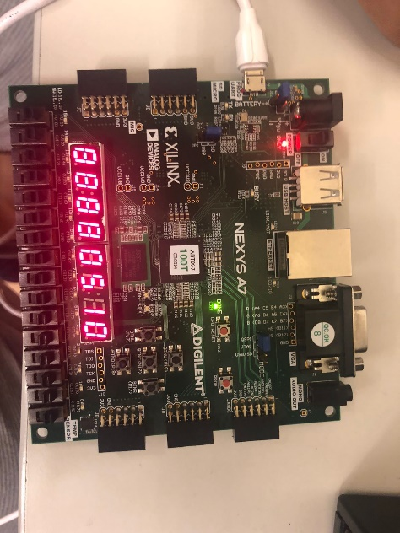The module instantiates an instance of the adder, passes A and B to it and the wire C for the output. It then passes C as input to the 7-segment module. We will be doing this for the other experiments as well.

1. Experiment # 2: For this experiment we modified the original code for the 7-segment driver from lab#1 to be able to display a signed 8-bit integer. We used 8 switches to toggle the bits for the integer and displayed it on the 7-segment display. A negative integer (MSB is 1) had a negative sign displayed in the thousand’s digit. The 7-segment module was the same used for lab#1 with a few additions:
   1. Wire sign: MSB of the input integer.
   2. Wire [7:0] twosComp: the two’s complement of the input integer, done by using the negation operator on the original number and adding 1 to it.
   3. Wire [7:0] correctNum: we use the ternary operator to assign the original number bits or the twosComp version by using the sign variable.

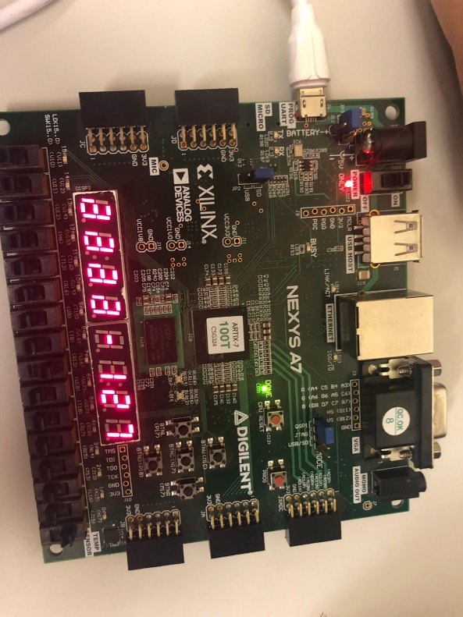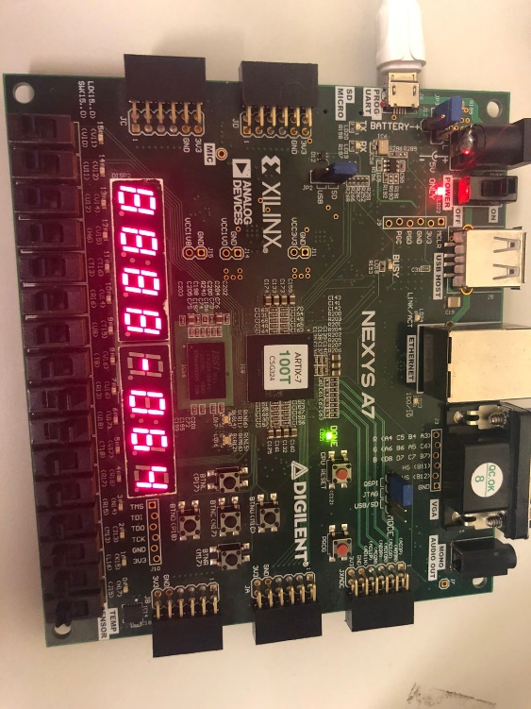In order to display the “-“ on one of the thousands digit, we check for sign variable, if it is a negative number we display the “-“ sign, if not we turn off the digit. We added two extra cases for the LED_BCD switch statement for that (Case 10: for “-“ sign, Case 11: for turning off the digit).

1. 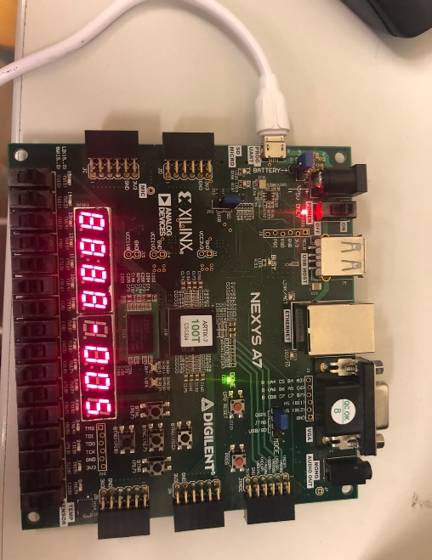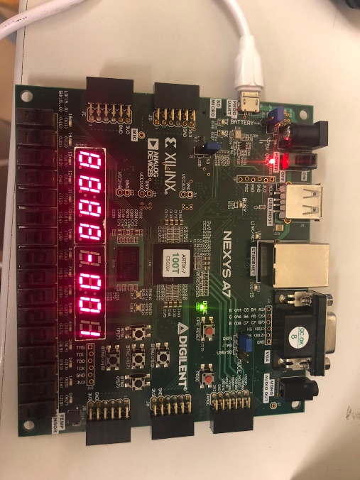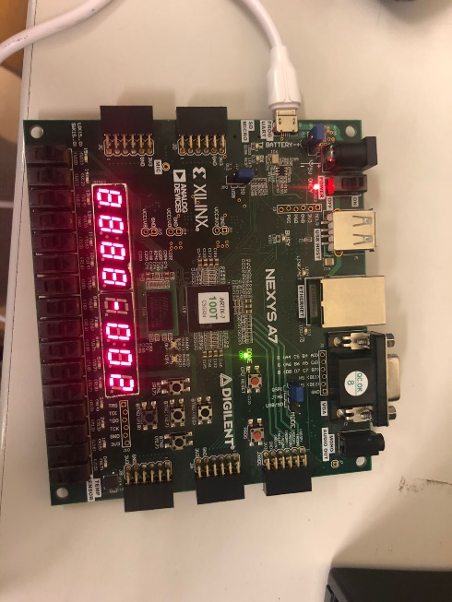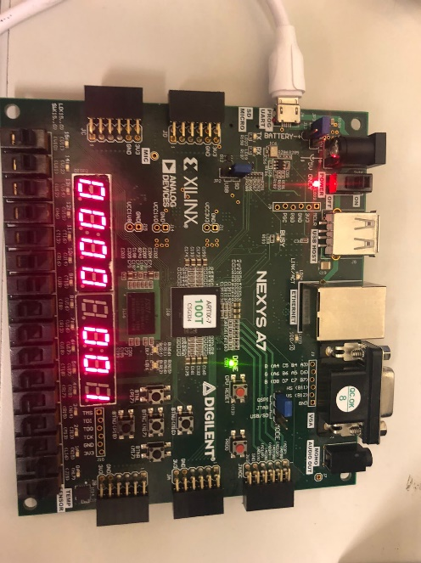Experiment # 3: In this experiment, we combined the modified 7-segment module from experiment 2 and modified the adder from experiment 1 to allow for addition of signed 8-bit integers. We simply removed discarded the Cout in the adder from experiment 1 to allow for signed addition.

**Differences in Utilization & delay between experiment 1 and 3:**

* Delay: There is more delay in experiment 3 as we need to compare the sign bit to assign to correct number to be displayed on the 7-segment display, whereas in Experiment 1 we did not do any comparisons and just outputted the number immediately.
* Utilization:
  + LUTs: Experiment 1 used 48 LUTs compared to 38 in experiment 3. In experiment 1 we outputted a 9-bit number whereas we outputted an 8 bit number in experiment 3.
  + FF: Both experiment 1 and 3 used the same number of flip flops(20).
  + I/O: Both experiment 1 and 3 used the same number of I/O ports as we used the same number of switches for both.

**Note: Timing report, uBlizaBon report and pictures of schema are aGached with this report.**